user documentation

Content:

Description------------------------------------------------------------------------------------------------ 2

Before login in:

Navigation bar1------------------------------------------------------------------------------------------- 2

OCDX page------------------------------------------------------------------------------------------------ 2

Login_in page--------------------------------------------------------------------------------------------- 3

Register page----------------------------------------------------------------------------------------------3

After login in:

Navigation bar2--------------------------------------------------------------------------------------------4

OCDX page-------------------------------------------------------------------------------------------------5

NewPost page----------------------------------------------------------------------------------------------6

Profile page -------------------------------------------------------------------------------------------------7

Login out page----------------------------------------------------------------------------------------------8

generate manifest page-----------------------------------------------------------------------------------8

Description:

a metadata specification (instantiated as an OCDX manifest) and infrastructure for storing, describing, analyzing, and sharing datasets for making sense of online human interactions. This work will enable scientists and citizens to answer fundamental questions about our society as it exists on the Internet.

Before login in:

(1.1)

Navigation bar1:



Choose the page you want to go in here through clicking appropriate button.

“OCDX Engine” -> OCDX page.

“Login”-> login-in page.

“Register”-> sign-up page.

OCDX page:

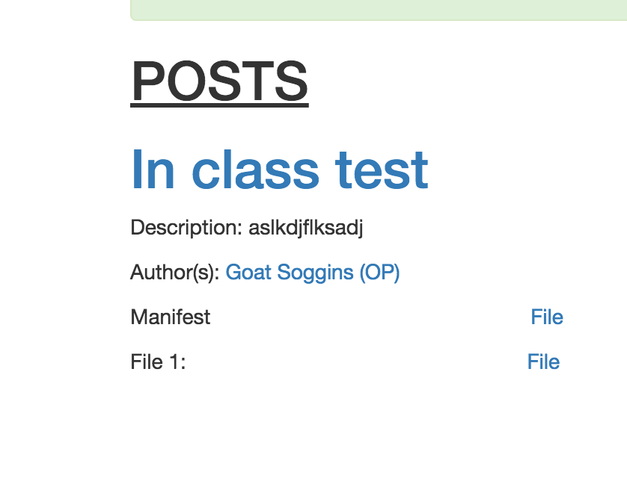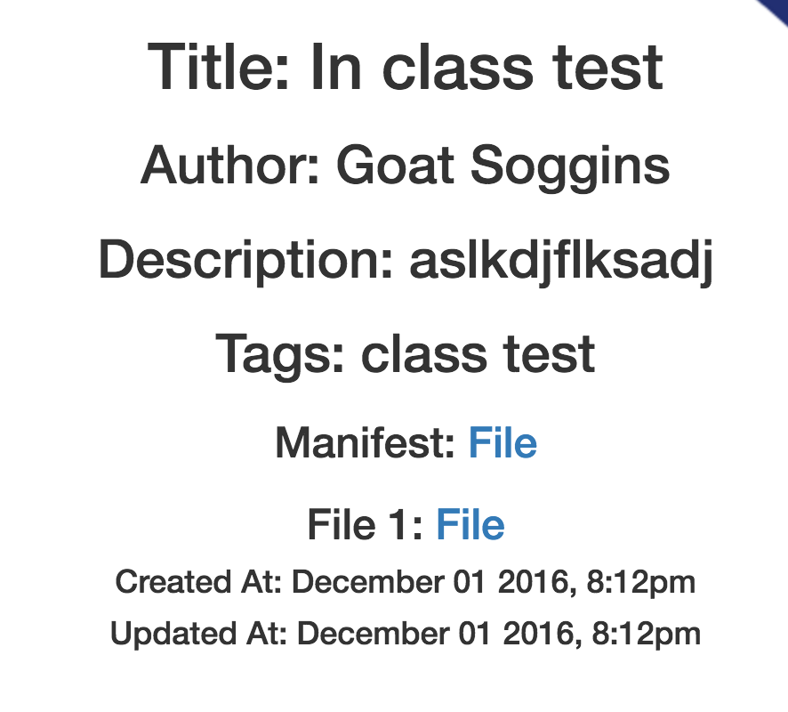

(1.2) (1.3)

we will post information in this page(1.2).If you want to look the detail of the file that you want to look. click the title link,it will go to file page and show the all detail of the post(1.3).if click the name of author,it will go to author page and show all information about this Authors.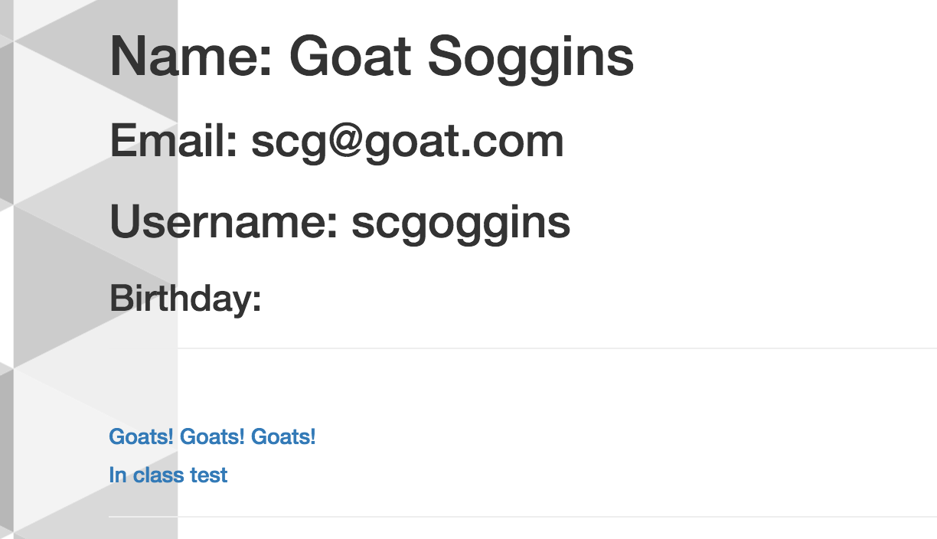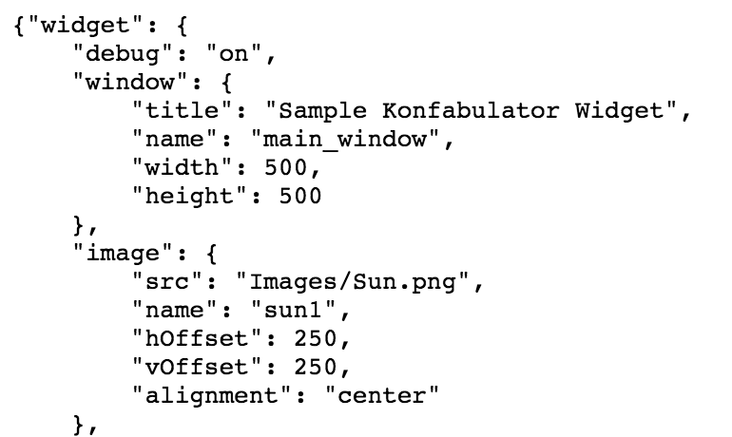

(1.4) (1.5)

when click “file” button,it will go to file page that shows the content of file(1.5).

Login_in page:

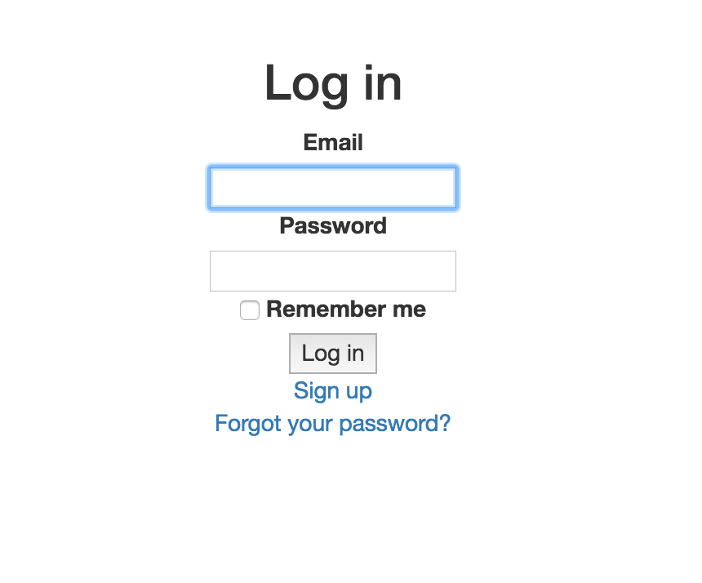

(1.7)

1.Enter your personal email and password, check it correct. And click login in button.

(if you are lazy and do not want to enter the e-mail and password again,click “Remember me”)

2.If you forget password, click “forgot your password?” . the password will automatically sent to your e-mail.

3. If you do not register before, click ”sign up” . You will go to register page (1.8)and can create your account in the register page.

Register page:

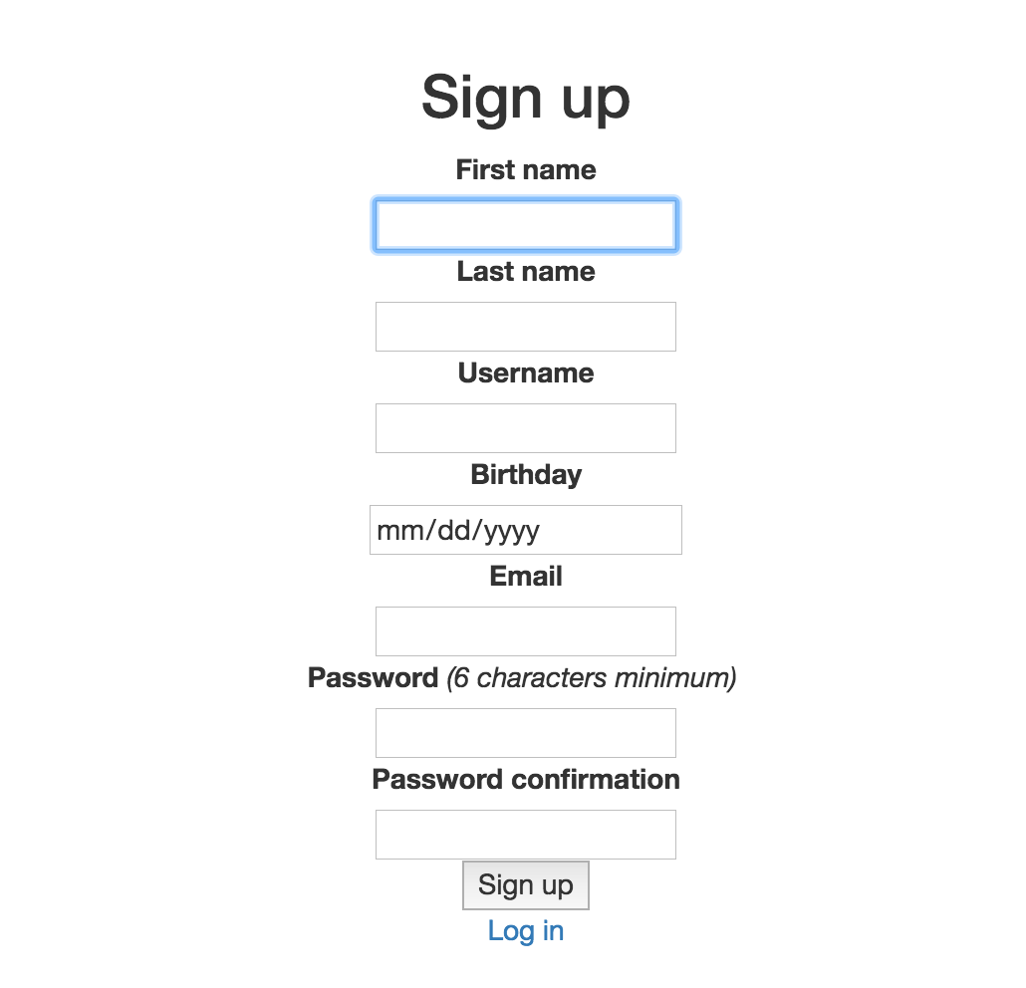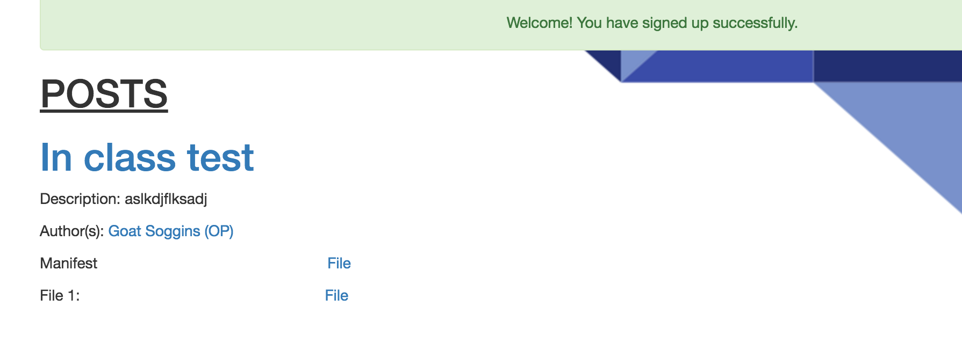

(1.8) (1.9)

Create your account in this page.

1.enter your First name and Last name.

2.enter your username(This is the your name that let others look in this system.)

ps: hope the username is not same as others,so create a unique username.

3.enter your birthday.

4.enter your e-mail: this is your account when you login in.

5.enter your password:at least 6 characters.

6.enter your password again: must be same as password you first enter.

7.check the information you enter. If think is correct, click “sign up” button.it will go to post page after login in page and tell you sign up successful(1.9).

After login in:

Navigation bar2:



(2.1)

1.Choose the page you want to go in here through clicking appropriate button.

“OCDX Engine” -> post page.

“New Post”->NewPost page.

“Profile”->profile page.

“Loginout”->Logout page.

“Generate Manifest”-> generate manifest page

2.if you want to search something, please enter the keywords in the seach box and click search button.if the search successful, it will shows all the post that have same keywords.(2.2)

.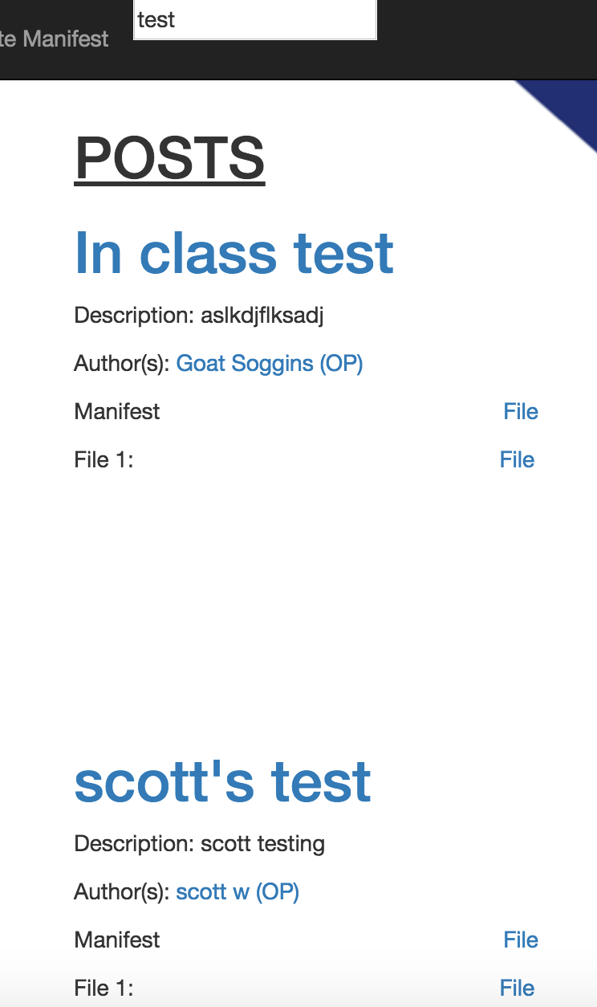

(2.2)

OCDX page:



(2.3)

we post file in this page.(most same as post page before login in)

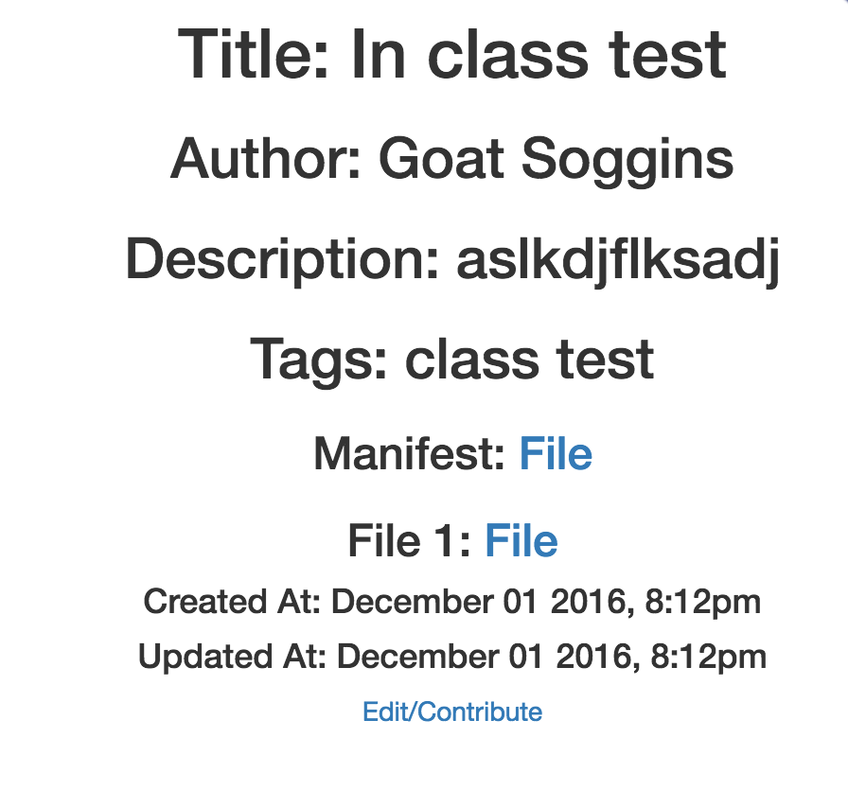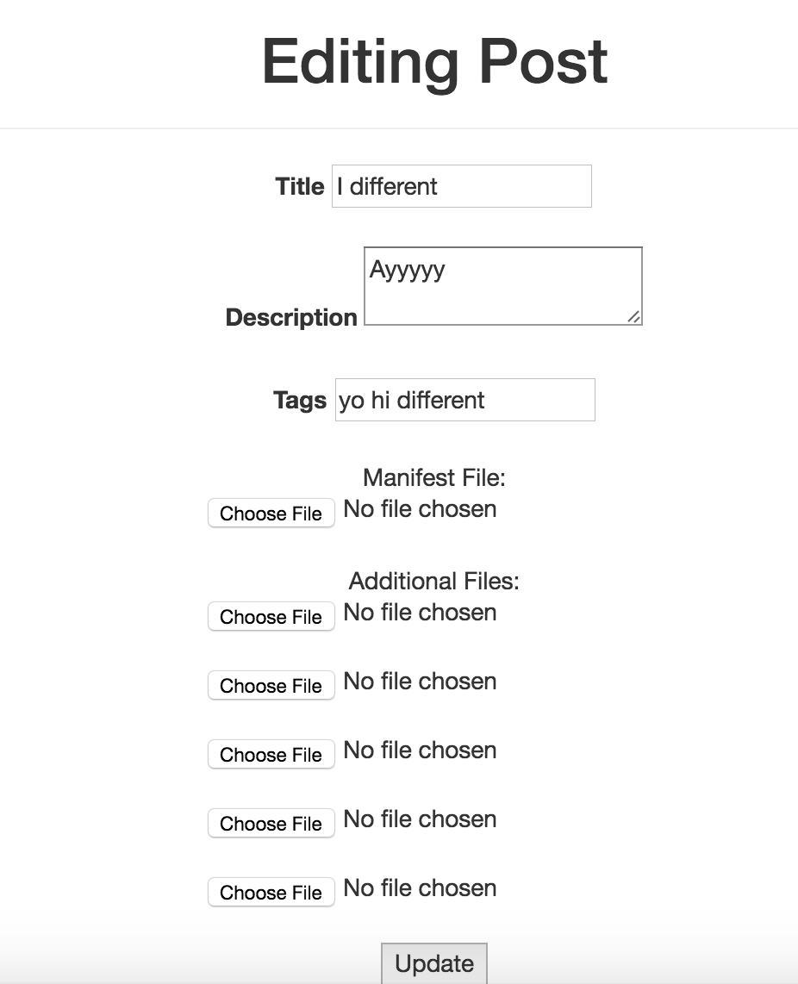

(2.4) (2.5)

it is different with post page before login in. when click title and go to file page,It has “edit/contribute” button(2.4). when you click “edit/contribute” button, it will go to editing post page. In this page, you can change information about this file and add more file and then click “update” button. All change will be saved.

NewPost page:

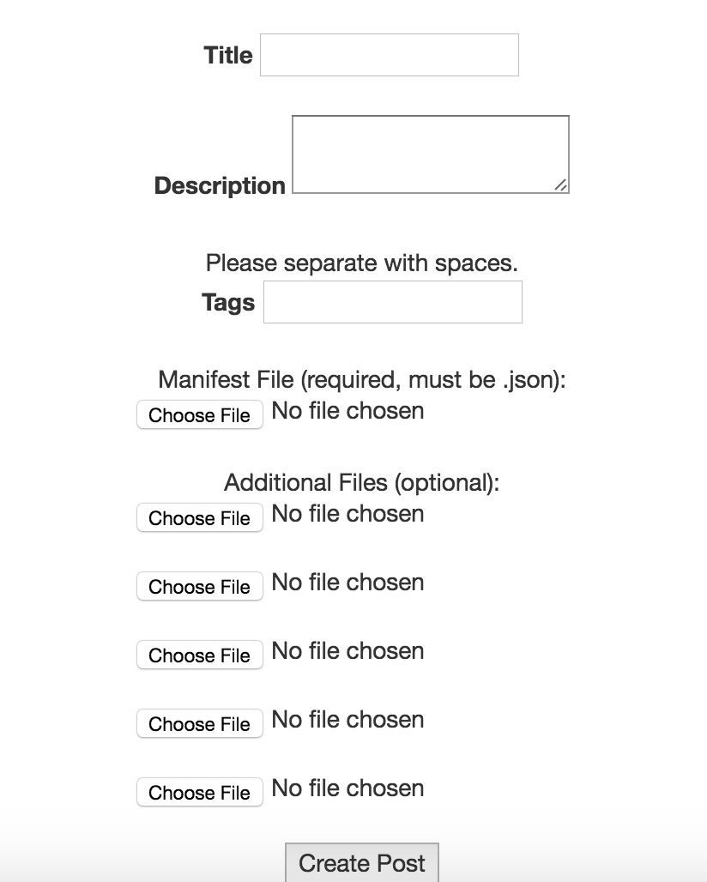

(2.6)

This page is for your new post.

1.enter the title.

2.enter descripton of your new post.

3.enter the tags

4.can choose many files(must be JSON file) you want to upload if you want to.

5.check the information that you enter and click “Create Post” button,your new post will show in the OCXD page.

Profile page:

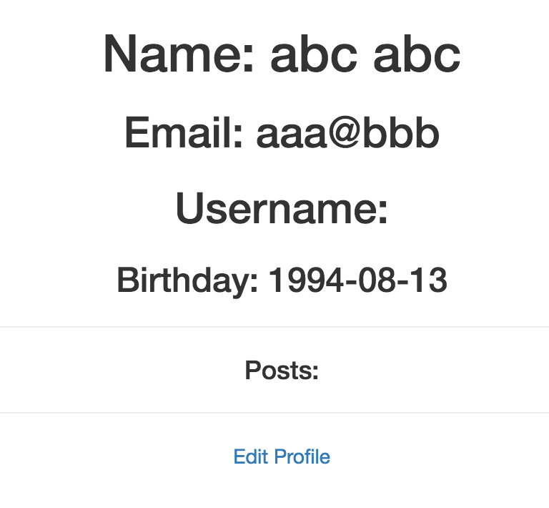

(2.7)

This page will show your all person information.(2.7).

If want to edit profile,please click “Edit Profile”.I will go to edit_profile page(2.8).

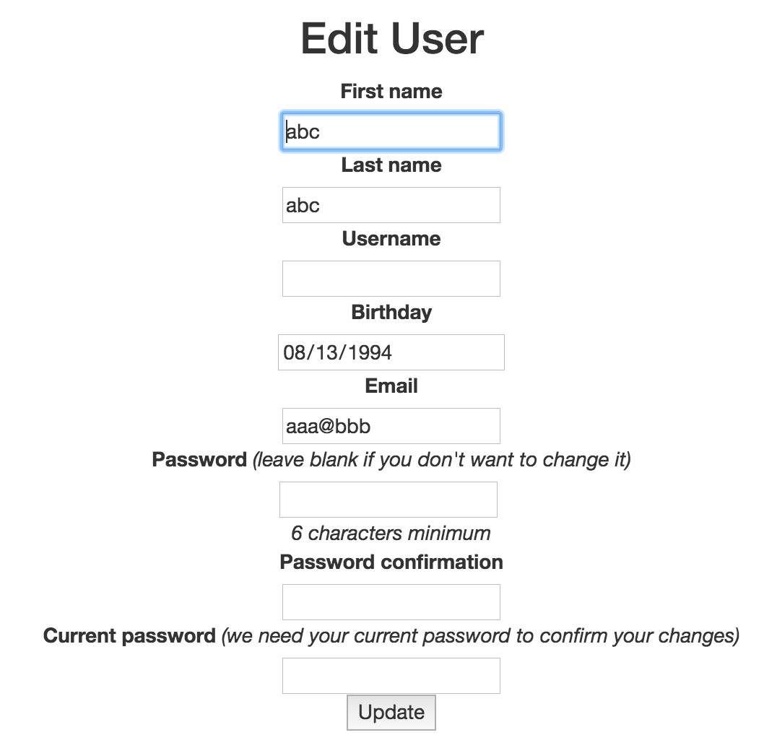

(2.8)

This page you can change everything you want to change and then click “update” button. your information will be changed.If you do not want to change password,please enter your current password in the last box.



(2.9)

If you do not like our system, you can cancel your accout in this page(2.9). Just click “cancel my account” button, we will delete your information and account.

Login out page:

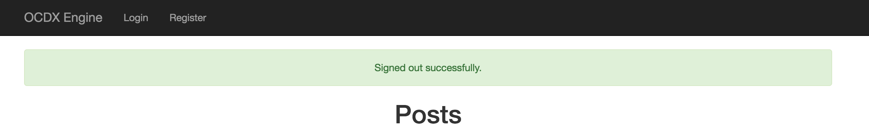

(2.10)

When click “Login out “ button, it will go to OCDX page before login in. And it will tell you signed out successfully. If you want to do something, login in again. If not,you can close the system.

Generate manifest page

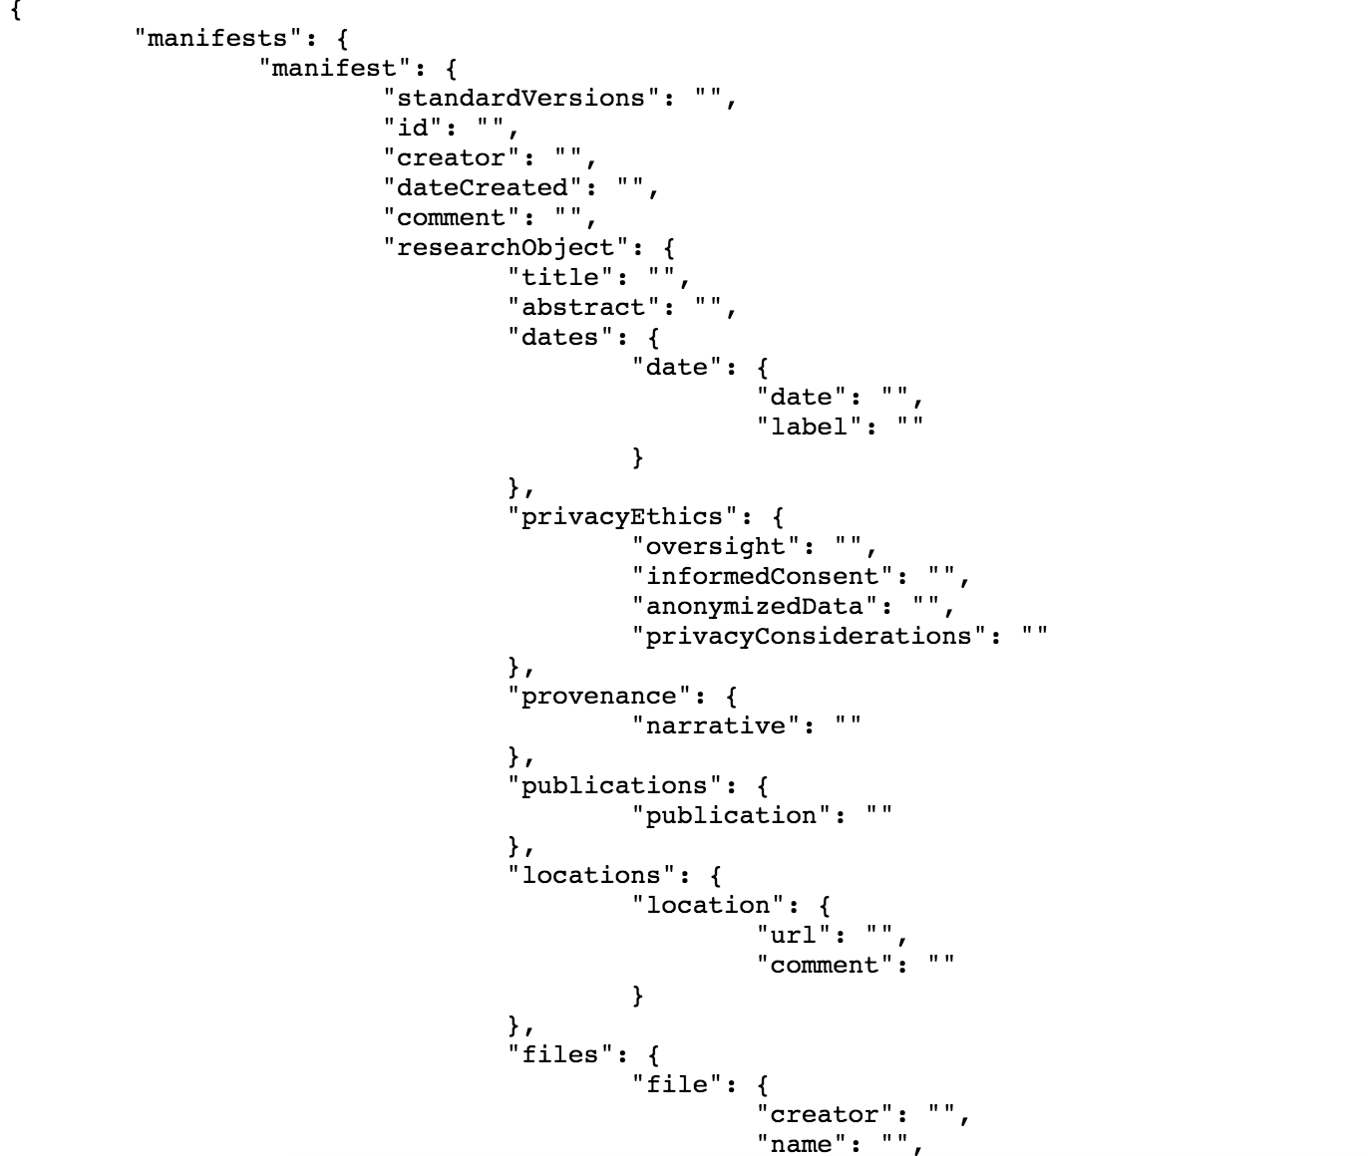

(2.11)

show information about generate manifest(2.11).